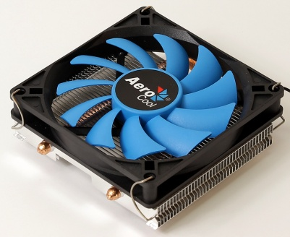
Product Overview:
Comes with 2 ultra-efficient thermal heat pipes. Compatible with HTPC and ITX chassis. PWM air cooling solution powered by Heat Core Touch Technology (HCTT) and equipped with high efficiency fins. Compatible with most current motherboard designs.

Model |  | Verkho 2 Slim
Base Material |  | Aluminum block with HCTT Heat Core Touch Technology
Fin Material |  | Aluminum
Heat pipe |  | 6mm x 2
Dimension |  | 92 x 102 x 34mm
TDP(Thermal Design Power) |  | 105
Fan | Speed | 1000-2300 rpm
 | Connector | PWM 4-Pin
 | Dimension | 90 x 90 x 15mm
 | Bearing Type | Hydraulic Bearing
 | Started Voltage | 5V
 | Rated Voltage | 12V
 | Rated Current | 0.14A
 | Power Consumption | 1.68W
 | Air Pressure | 0.58-1.01 mm/H2O
 | Air Flow | 21.5-48.8 CFM
 | Noise | 18.3-26.7 dBA
 | MTBF  (Mean Time Before Failure) | 60000 hrs.
Socket |  | LGA 1156/1155/1151/1150/775 AM4/AM3+/AM3/AM2+/AM2/FM2/FM1

Warranty

1 year

Features

- TDP (Thermal Design Power) up to 105W.
- Compact side flow air cooler for maximum compatibility.
- Heat Core Touch Technology and 2 ultra-efficient thermal heat pipes.
- Upgraded high efficiency fins for optimal thermal performance.
- Compatible with HTPC and ITX chassis.

Package Information

Product Name | Product Number | EAN CODE | UPC CODE
Verkho 2 Slim
Carton Size ( L x W x H ) | 495 x 375 x 300 mm | Carton Weight
Retail Box Size ( L x W x H ) |  | Retail Box Weight
Carton Qty | 36 pcs | Pallet Qty

